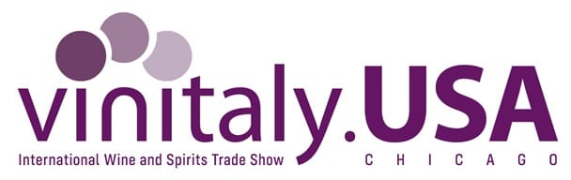


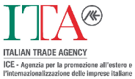

Vinitaly Usa: Veronafiere and the ITA Italian Trade Agency welcome Gambero Rosso to expand the Italian wine promotion team. Aamerican preview of the Tre Bicchieri 2025 awards scheduled 20-21 October in Chicago

Verona - 8 August 2024. Veronafiere and the ITA Italian Trade Agency have further strengthened the team promoting Italian wine world-wide with the involvement of Gambero Rosso in Vinitaly USA, scheduled in Chicago 20-21 October. This occasion will see the preview for the American market of the approximately 500 labels earning Tre Bicchieri awards in the coming 38th Italian Wine Guide 2025, the highest recognition in the leading ranking of the finest Italian wines. This is one of the most important news items for the first edition of the two-day b2b event organized by Veronafiere and Fiere Italiane at the Navy Pier Exhibition Center, in synergy with the ITA Italian Trade Agency and in collaboration with the Italian American Chamber of Commerce in Chicago.

The joint efforts of Veronafiere and the ITA Italian Trade Agency to strengthen the event and its authoritative status brought about the onset of the partnership between Vinitaly and Gambero Rosso at 'Casa Italia' scheduled in Chicago. Hundreds of buyers selected above all by the ITA Italian Trade Agency are expected at Vinitaly USA within the scope of activities designed to upgrade the database of reference operators. The objective is to ensure qualified and authoritative attendance of importers, distributors and buyers at the event in Chicago, following discussions with sector professionals, which will be crucial for the success and development of the wine business on the US market in such complex times. Hundreds of wineries from the North to South of Italy are also taking part in the B2B show, joined by already confirmed group shows by Friuli-Venezia Giulia, Sardinia, Campania, and Lazio-Arsial.

As well as the Tre Bicchieri walk-around tasting, the Gambero Rosso calendar developed for Vinitaly USA also includes two master classes: the first will focus on the special awards in the new edition of the Guide - the 'best of the best' - and the other on 'Tre Bicchieri Beginners' (20-21 October).

As regards the overall schedule currently being finalised, Vinitaly USA includes sessions of the Vinitaly international Academy (19, 20 and 21 October), guided master classes, including those organised by Wine Enthusiast and Decanter. Michaela Morris, on her part, will lead the iconic tasting of the six wines earning the World Wine Awards. These events will be joined by Vinitaly Tasting, the 'wine point' highlighting a selection of 66 labels for international trade operators.

The feeling between American demand and Italian supply will be the main distinctive feature of Vinitaly Chicago, the first authentic Italian Wine Fair in the USA. With wine imports coming to almost 335 million litres, Italy confirms its status as the market leader in the United States in terms the volume of wine purchased every year. The Italian share of the wine market is double that of the main competitor, France, with US imports worth almost 2 billion euros. The Vinitaly-Uiv Observatory (Italian Wine Union) indicates that in the first quarter of this year, Italy achieved positive sales (+2%, up to 468 million euros), compared to an

overall fall in imports in the period of 6%, with France at -12%. Over the last 5 years, the value of Italian wine exports to the United States has especially been driven by Prosecco, posting growth of 109%.

Veronafiere Media and Institutional Relations
Francesco Marchi | marche@veronafiere.it | T. 045 8298350
E-mail: pressoffice@veronafiere.it;
X: @VRfiere | Facebook: @veronafiere
Web: www.veronafiere.it / www.vinitaly.com

Ispropress
Benny Lonardi (393.455.5590; direzione@ispropress.it)
Simone Velasco (327.9131676; simovela@ispropress.it)

